Physics 30 Lesson 12 Diffraction Gratings

# Poisson’s bright spot

Thomas Young published the results from his double-slit experiment (Lesson 11) in 1807 which put the wave theory of light on a firm footing. However, so strong was Newton’s reputation and his corpuscular theory of light that Young’s results were not accepted until more than ten years later when, in 1819, Augustin Fresnel (1788–1827) presented to the French Academy a wave theory of light that predicted and explained interference and diffraction effects. (Refer to Pearson pages 691 to 692.)

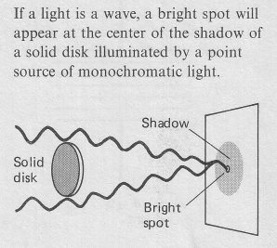Almost immediately after Fresnel introduced his wave theory, Simeon Poisson (1781–1840) pointed out what at first appeared as a counter-intuitive inference: that according to Fresnel's wave theory, if light from a point source were to fall on a solid disk, then light diffracted around the edges should constructively interfere at the center of the shadow. In other words, a bright spot should appear in the center of the shadow. That prediction seemed very unlikely. After attempting the experiment and failing to demonstrate the existence of a bright spot, Poisson claimed that he had refuted Fresnel’s theory.

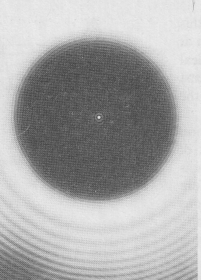

But when the experiment was redone by Francois Arago in 1818, the bright spot was seen at the very center of the shadow! This was strong evidence for the wave theory and it was ironically referred to as Poisson’s Bright Spot. To the right is a photograph of the shadow cast by a coin using a (nearly) point source of light (a laser in this case). The bright spot is clearly visible at the center. Note that there are also bright and dark fringes beyond the shadow. These resemble the interference fringes of a double slit. Indeed, they are due to interference of waves diffracted around different parts of the disk, and the whole is referred to as a diffraction pattern.

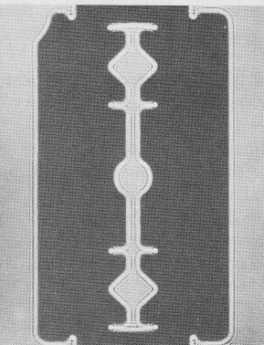

A diffraction pattern exists around any sharp object illuminated by a point source, as shown in the photograph of a razor illuminated with laser light. We are not always aware of diffraction effects in our everyday life since most sources of light in everyday life are not point sources – so light from different parts of the source wash out the pattern.

# Diffraction gratings

A large number of equally spaced parallel slits is called a **diffraction grating**. (Refer to Pearson pages 692 to 694.) Gratings are often made by ruling very fine lines on glass with a diamond tip. The spaces in between the lines serve as slits. Gratings containing more than 10 000 slits per centimetre are common today. A double slit apparatus produces an interference pattern where the fringes tend to be broad and relatively undefined. Diffraction gratings produce very sharp and well defined bright fringes and dark fringes. Check out the video clip called **P30 L12 Diffraction interference** in D2L. The video shows how different colours (i.e. wavelengths) of light are diffracted by different amounts.

A similar derivation like the one demonstrated for the double slit apparatus in Lesson 11 produces the same equations for finding the angle and location of nodes and anti-nodes.



where:

● wavelength (m)

❑ angle from central line to fringe

n order of fringe

L distance from slits to screen (m)

x distance from central bright fringe to nth fringe (m)

d distance between slits (m)

The main difference in calculating variables between double slit problems and diffraction gratings is the way that slit separation is reported for diffraction gratings. Say, for example, a diffraction grating has 5000 lines/cm. To find the distance **d** between the lines requires two steps:

1. Calculate the number of lines per metre.



2. To find **d**, simply invert  to obtain .



A monochromatic light source shines on a diffraction grating of 10 000 lines/cm and produces a first order antinode 40.5o off the centre line. What is the wavelength of the light?



❑ = 40.5o

n = 1

● = ?



A monochromatic light source shines on a diffraction grating of 10 000 lines/cm and produces a first order antinode 65 cm off the centre line on a screen 100 cm away. What is the wavelength of the light?

Note that the requirement to use the equation in step 2 requires that either <10o or x<<L. In this case x is quite large compared to L. From the geometry we can calculate .

❑

100 cm

65 cm



x = 0.65 m

L = 1.00 m

n = 1

● = ?



# Practice problems

1. At what angle is the third maximum for 700 nm light going through a 2000 line/cm diffraction grating? (24.8o)

2. In an interference experiment, red light with a wavelength of 6.00 x 10-7 m passes through a diffraction grating. On a screen 1.50 m away, the distance to the second antinode is 0.463 m. How many lines/cm have been etched into the diffraction grating? (2.57 x 103 lines/cm)

# Hand-in assignment

1. Green light of wavelength 5000 Å (1 Å = 10–10 m) is shone on a grating and a second order image is produced at 32o. How many lines/cm are marked on the grating? (5300 lines/cm)
2. How many lines per metre does a diffraction grating have if the 2nd order minimum occurs at an angle of deviation of 16.0o when 530 nm light is used? (3.47 x 105 lines/m)
3. 650 nm yellow light is incident on a diffraction grating which has 150 lines/cm. What is the spacing between the bright fringes produced as a result on a screen 4.9 m away? (4.8 cm)
4. Light of frequency 5.0 x 1014 Hz falls on a diffraction grating which has 4.2 x 103 lines/cm. At what angle will the third antinodal line be inclined to the forward direction? (49o)
5. A grating is ruled with 1000 lines/cm. How many orders of spectra are possible on either side of the central maximum for 700 nm red light. (14)
6. A light ray of frequency 5.0 x 1014 Hz is incident on a diffraction grating that has 180 lines/cm. After passing through the grating the light travels 4.0 m in a trough of water to a screen where it produces an interference pattern. How far apart are the bright fringes on the screen? (3.2 cm)
7. The wavelength of a laser beam used in a compact disc player is 790 nm. Suppose that a diffraction grating produces first-order tracking beams which are 1.20 mm apart at a distance of 3.00 mm from the grating. Estimate the spacing between the slits of the grating. (2.13 x 10-6 m)
8. Monochromatic light with a frequency of 5.50 x 1014 Hz is directed onto a diffraction grating ruled with 6000 lines/m. What is the distance between the 3rd bright band and the 5th dark band of the interference pattern formed on a screen 2.50 m from the grating? (1.23 cm)
9. A student using a diffraction grating ruled with 6.20 x 104 lines/m to measure the frequency of some monochromatic light. If the nodal lines are 0.0522 m apart at a distance of 1.50 m from the grating, what is the frequency of the light used? (5.3 x 1014 Hz)
10. Using the information in question 9, determine the distance between nodal lines if the grating was changed to 9.30 x 104 lines/m while all other variables remained unchanged. (7.83 cm)
11. Using the information in question 9, determine the distance between nodal lines at a distance of 3.00 m if all other variables remained unchanged. (0.104 m)
12. Using the information in question 9, determine the distance between nodal lines if the frequency of the light was changed to four-fifths of its original while all other variables remained unchanged. (6.5 cm)

Activity – Diffraction Gratings

Purpose:

To measure the wavelengths of red and violet light.

Apparatus:

The diagram below is a top view of the set-up.

diffraction grating

observe from here

1.0 m

light source

metre stick

metre stick

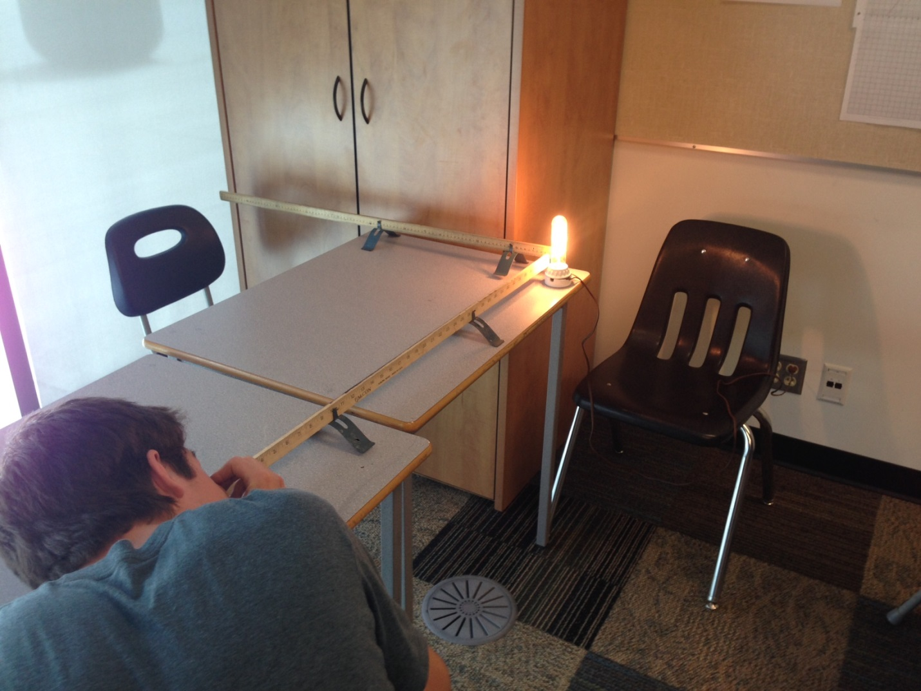

Procedure:

1. Set up the apparatus as shown. Make sure the metre sticks are at right angles.
2. Make measurements for each colour red and violet for the first order interference pattern.

Observations:

Set up a data table to organise your results.

Analysis:

1. Show all calculations for finding the wavelengths of red and violet light.

2. How do your results compare with the values in Table 13.5 in Pearson page 676?

3. Give at least two sources of error.